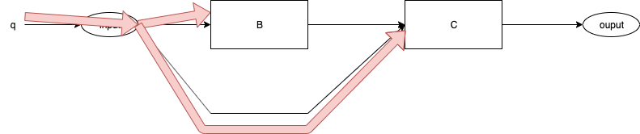
Fig. <$n:figure:SyncVsAsync_SyncControlFlow> Event q Delivered

Fig. <$n:figure:SyncVsAsync_SyncControlFlow> shows event "q" being delivered to B and C.

Nothing else happens, no routines are called.

